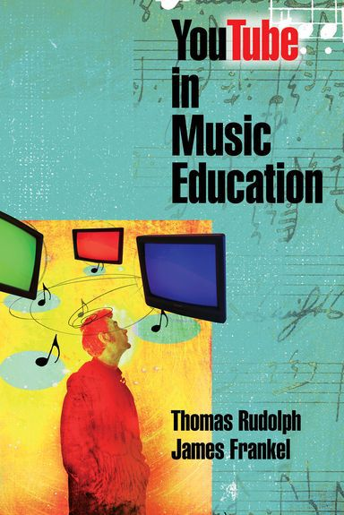
Uploading Videos to YouTube
Music Education Applications
By Tom Rudolph
tom@tomrudolph.com
www.tomrudolph.com

From the book “YouTube in Music Education”

SoundTree Webinar
Tuesday, May 14, 2013
7:00-8:00 pm

Part 1: Selecting the Equipment
- The camera and necessary accessories
- External microphone
- Computer video editing software to create the final version of your videos

Using a Webcam or Computer build-in Camera

- Using a Video Camera
- Kodak PlayTouch Video Camera - $90-$120

- Floor standing tripod for your video camera.

Sony VCT-R100 Lightweight Compact Tripod with 3-Way Pan/Tilt Head - $34.99

- External Microphone
  - Audio-Technica ATR-3350 Lavalier Omnidirectional Condenser Microphone

- Video Editing Software
  - Comes with most Cameras.
  - I recommend using Apple’s QuickTime Pro for Mac and Windows ($29.99). https://www.apple.com/quicktime/extending/
  - Also iMovie (Mac) and Moviemaker (Windows)

- Upload to YouTube use Apple QuickTime 10.2 (free for Mac and Windows)

- Screencasts
  - Apple QuickTime 10.2 can also be used to create a screen cast of the computer screen. http://www.apple.com/quicktime/download/

PART 2: Uploading Videos:

- Know your YouTube email and password.

- Upload from the Camera or QuickTime.

- Make the settings as you desire
  - Private
  - Teacher-controlled comments

- Share the Web link to the video.

PART 3: Teaching Applications

- Teacher tutorials and lessons for students to view.
  - Screen casts of the computer
  - Live recordings
  - Interviews
  - Lessons

- Student performances for students and parents.
  - Students can make comments about videos (approved by teacher)

- Students upload recordings of a performance or practice session.

